Microscopy Image Analyzer - MIA

**Introduction:**

When working with images taken through microscopy, it is often needed to take accurate measurements of objects within the image. Although approximations can be obtained by using a scale bar along the glass slides, this method does not provide an accurate reading of objects further away from the scale bar; furthermore, the measurement uncertainty increases as the distance between the measured object and the scale bar increases.

This implementation allows to take microscopy measurements having a measurement pattern with the optical settings of the microscope used. Furthermore, the measurements made can be quantified using a user-defined scale. In the software, images of the measurements can be exported with the microscopy scale bar given by the user. Thus, it provides a faster and more accurate way of taking reliable measurements of microscopy images.

**System Requirements:**

The program requires Microsoft Windows 7 or newer with .net framework 4.5 o newer.

**Components Explanation:**

The software components can be observed in the following illustration.

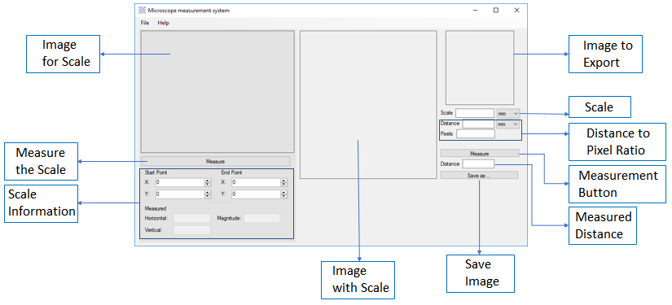

Illustration 1: Software Interface

**Operation:**

By executing the application, the interface shown in illustration 1 will appear. Illustration 2 shows the flow diagram for the correct operation of the software. The illustration can be observed below.

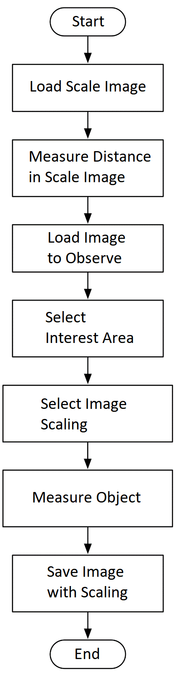

Illustration 2: Software Flow Diagram

The images are loaded by dragging them to each of the spaces. The scale image must be one that has an element in which the length is known. It should be noted that for the proper operation, the measurements have to be known in both standard units as well as pixels.

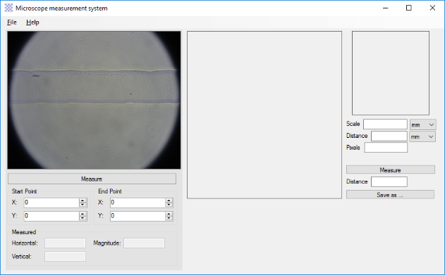

Illustration 3: Software Initialization Interface

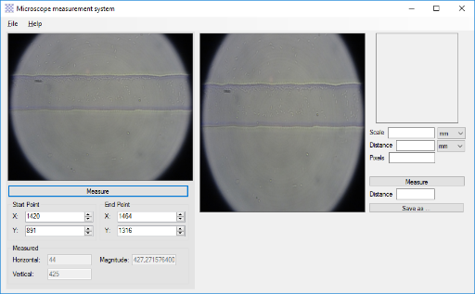

Illustration 4: Software Interface Scale

Perform the distance measurement in pixels of the element whose measurement is known, for this example the size of the channel is 60um, which is equivalent to approximately 425 pixels. For the measurement press the Measure button, and then click twice on the Image for Scale on the screen. The program calculates the horizontal and vertical distance and the magnitude of pixels between both points. The obtained size and measurement data are then loaded.

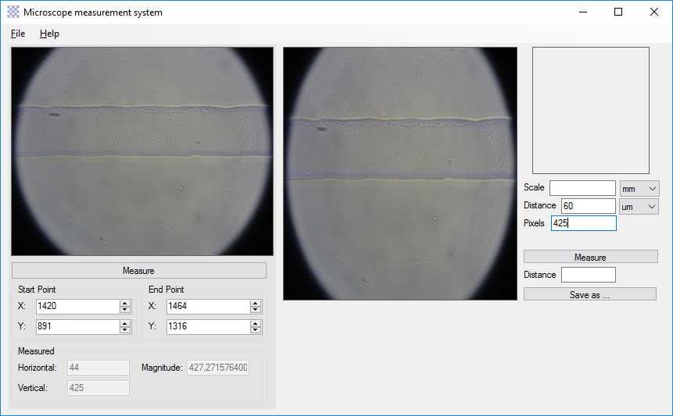 

Illustration 5: Software Calculation Points Illustration 6: Software Scale Calculations

The area for calculation is selected by clicking and moving the mouse in the Image with Scale. After having creating the calculation area, the size of the scale bar is defined (10um for the example), and the measurement is carried out. This is observed in illustration X. For the actual measurement, press the Measure button, and then two clicks are made on the screen, the program calculates the distance in pixels between both points. The program also generates a distance value for the selected points, which can be observed in red.

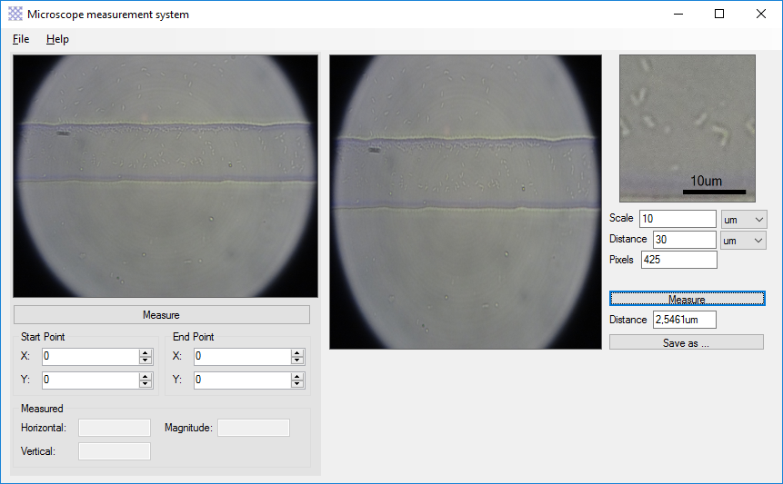 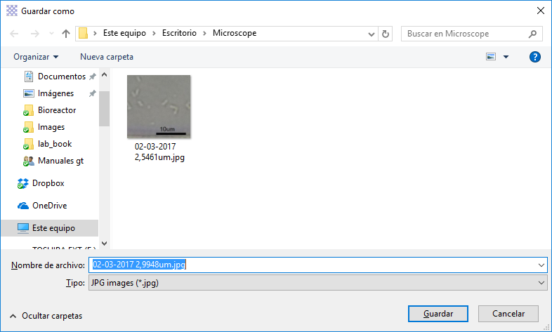

Illustration 7: Image Scaling Illustration 8: Saved Image

By clicking the Save As button, a file directory opens to save the image, the default name contains the date and the measurement value, the result is an image like the one presented in illustration X.

**Recommendations:**

It should be noted that higher resolution images provide a better product, as the software scales up the image according to the calculation points of the Image with Scale.